Pizza Sales

KPI’s:

1. **Total Revenue:**

**select sum(total_price) as Total_Revenue from pizza_sales**

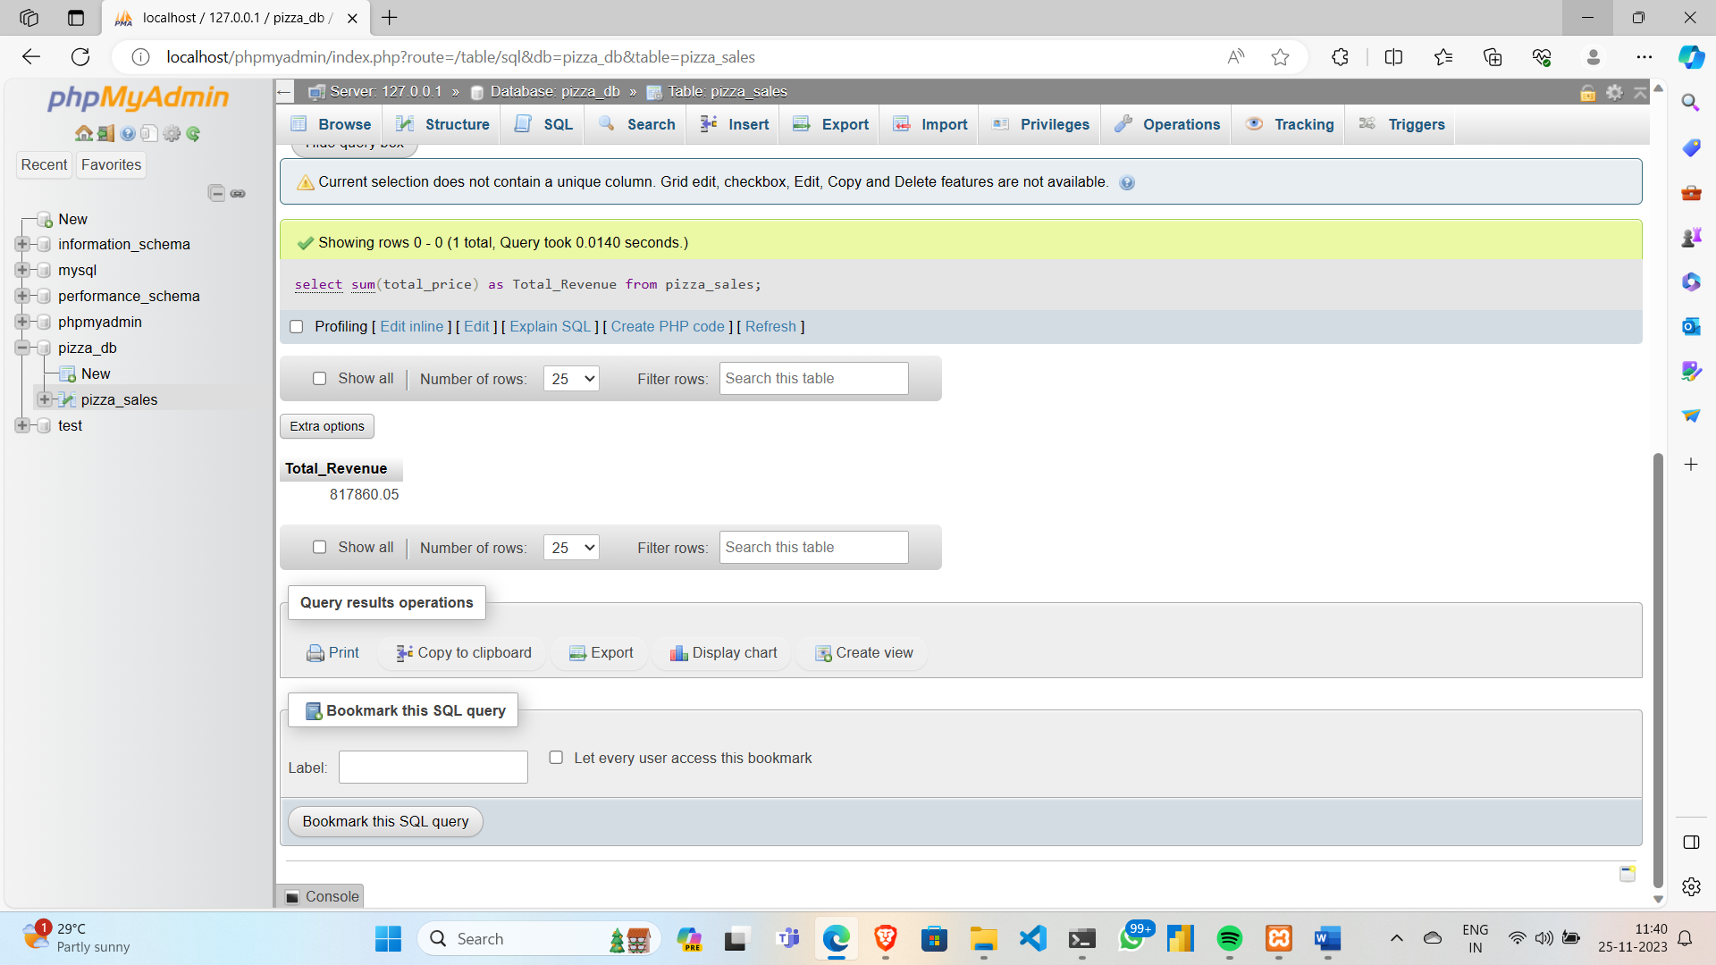

1. **Average_Order_value:**

**select sum(total_price)/count(DISTINCT order_id) as Avg_order_value from pizza_sales**

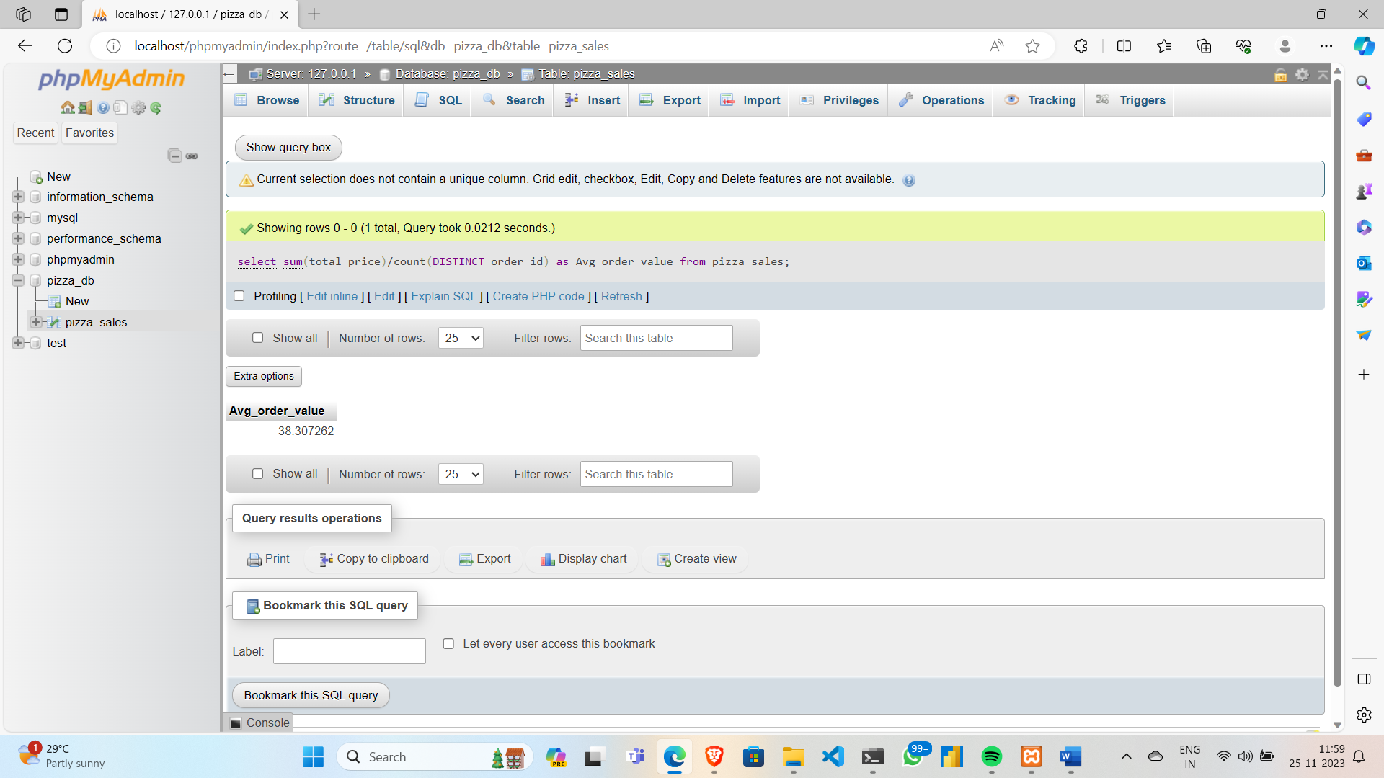

1. **Total pizzas sold:**

**SELECT sum(quantity) as Total_pizza_sold from pizza_sales**

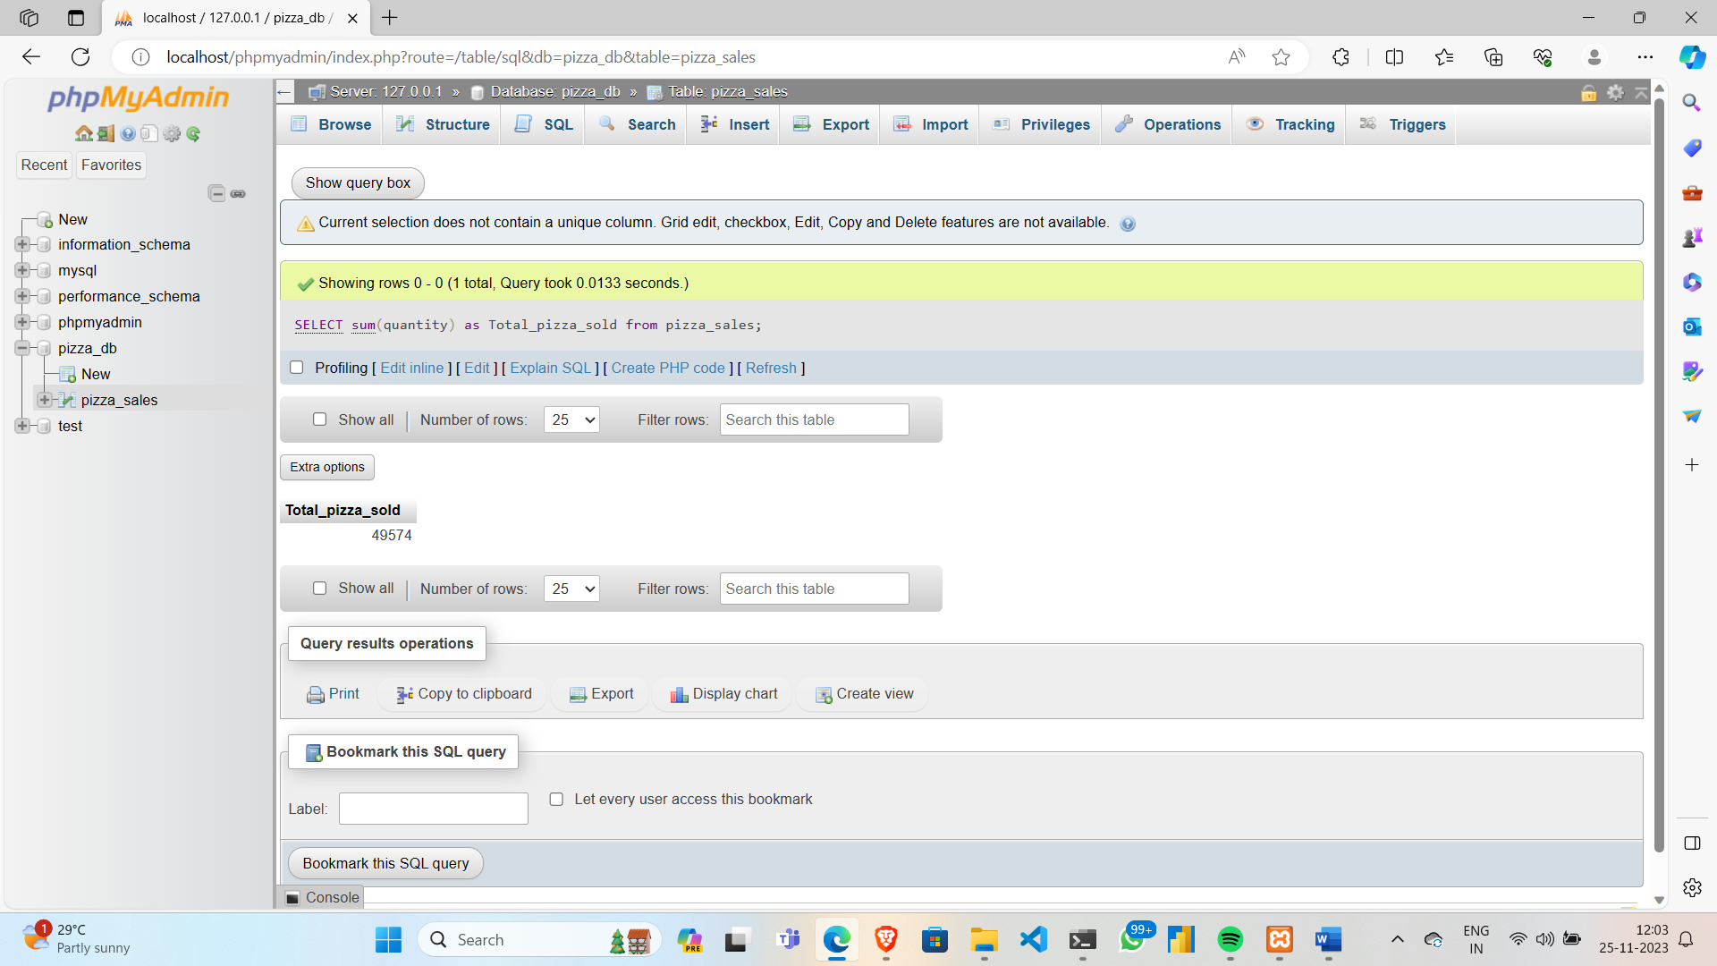

1. **Total orders:**

**SELECT count(DISTINCT order_id) as Total_orders from pizza_sales**

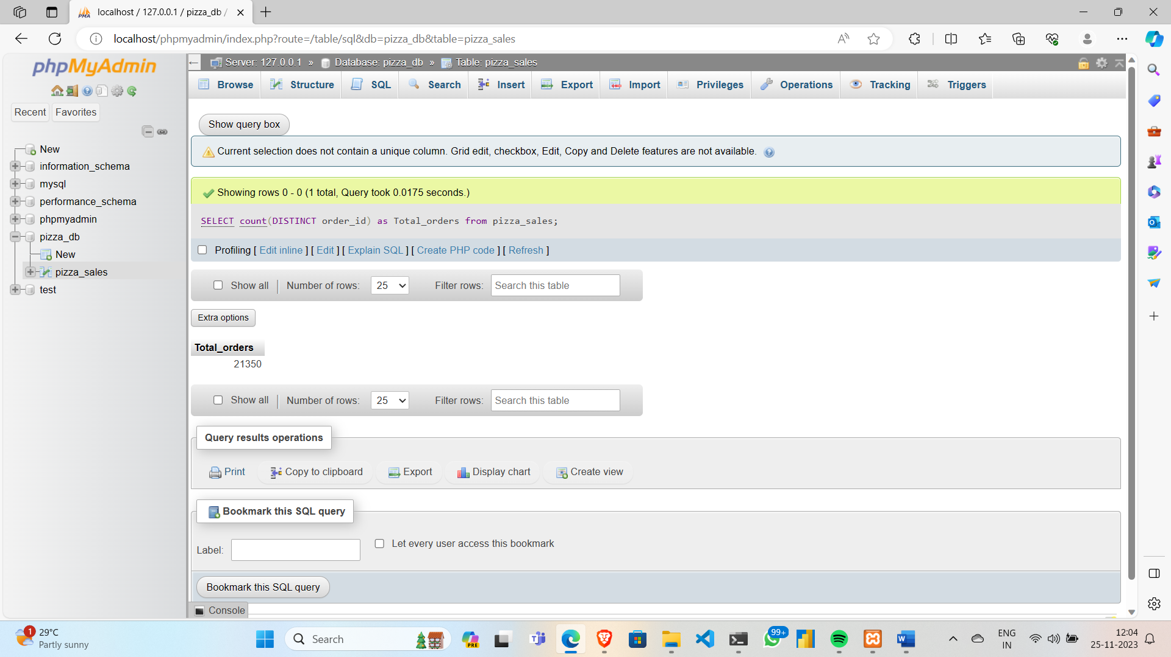

1. **Average pizzas per order:**

**SELECT sum(quantity)/count(DISTINCT order_id) as Avg_pizzas_per_order from pizza_sales**

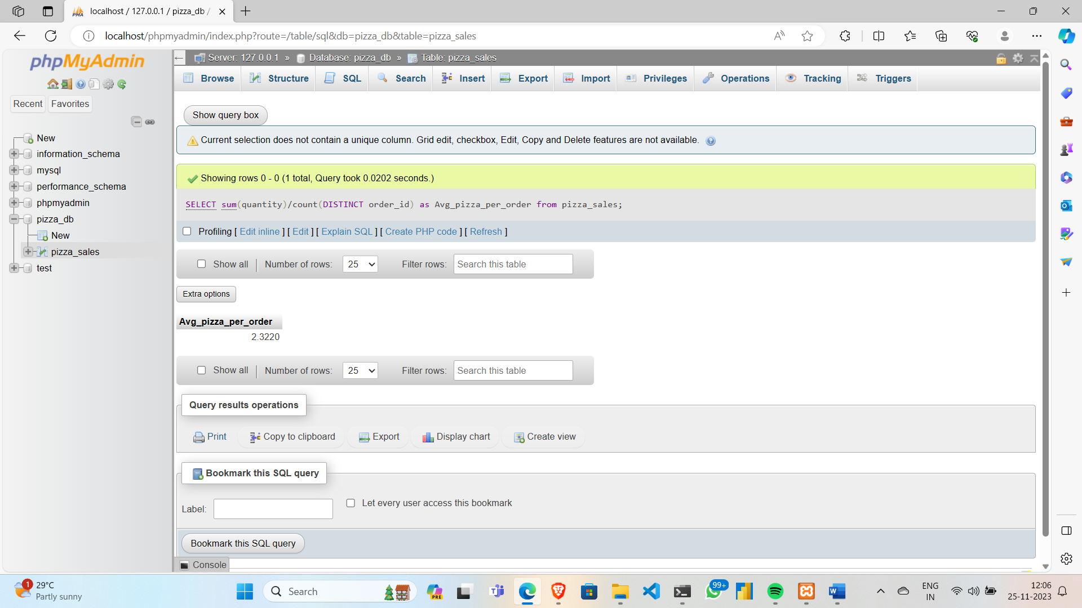

**Charts :**

1. **Daily trend for total orders:**

**SELECT dayname(order_date) as order_day, count(DISTINCT order_id) as total_order**

**FROM pizza GROUP BY order_day**

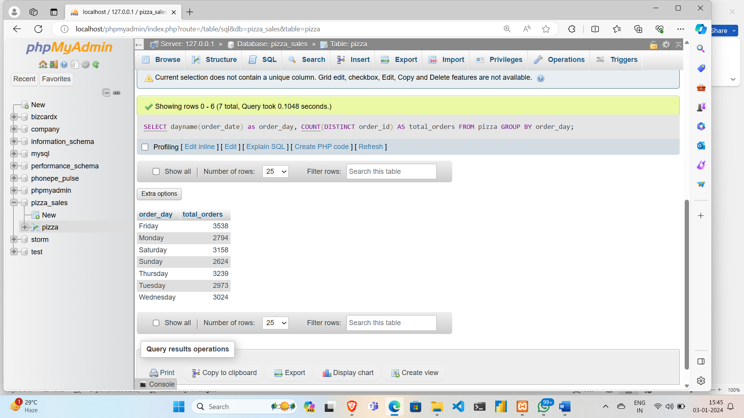

1. **Monthly trend for total orders:**

**SELECT monthname(order_date) as month_name, count(DISTINCT order_id) as total_order**

**FROM pizza GROUP BY month_name**

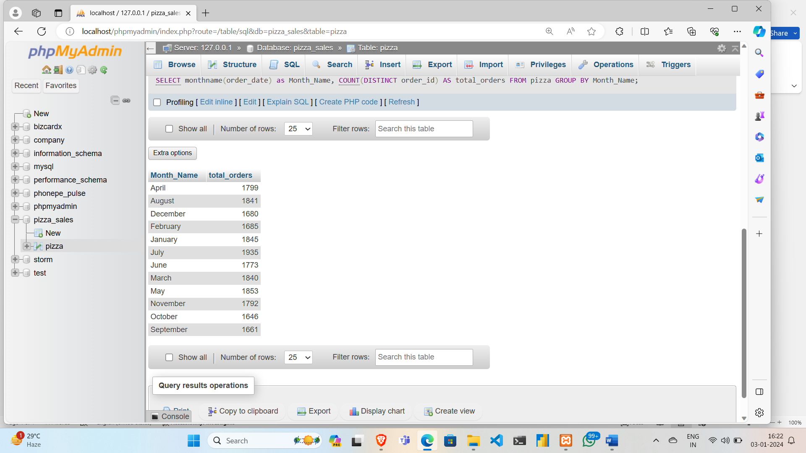

1. **Percentage of sales by pizza category:**

**SELECT pizza_category, cast(SUM(total_price) as decimal(10,2)) as total_revenue,**

**cast(SUM(total_price) * 100 / (SELECT SUM(total_price) FROM pizza) as decimal(10,2)) as PCT**

**FROM pizza GROUP BY pizza_category**

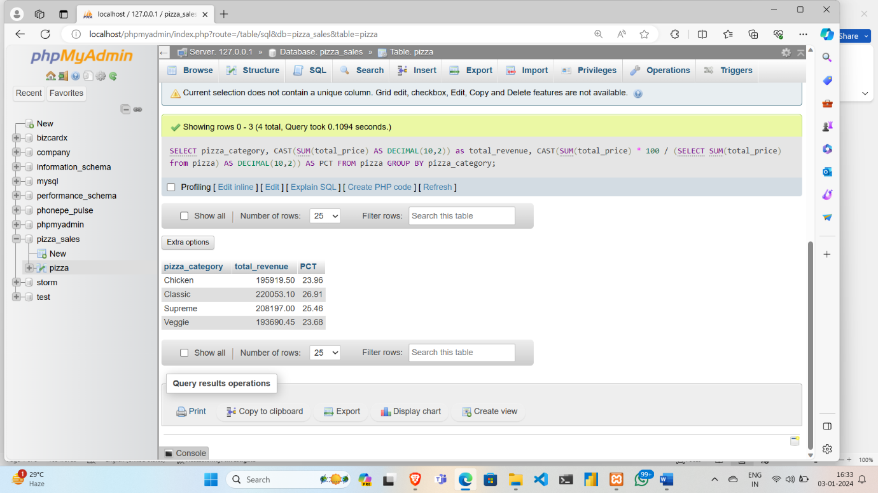

1. **Percentage of sales by pizza size:**

**SELECT pizza_size, SUM(total_price) as total_revenue,**

**SUM(total_price) * 100 / (SELECT SUM(total_price) FROM pizza) as PCT FROM pizza**

**GROUP BY pizza_size ORDER BY pizza_size**

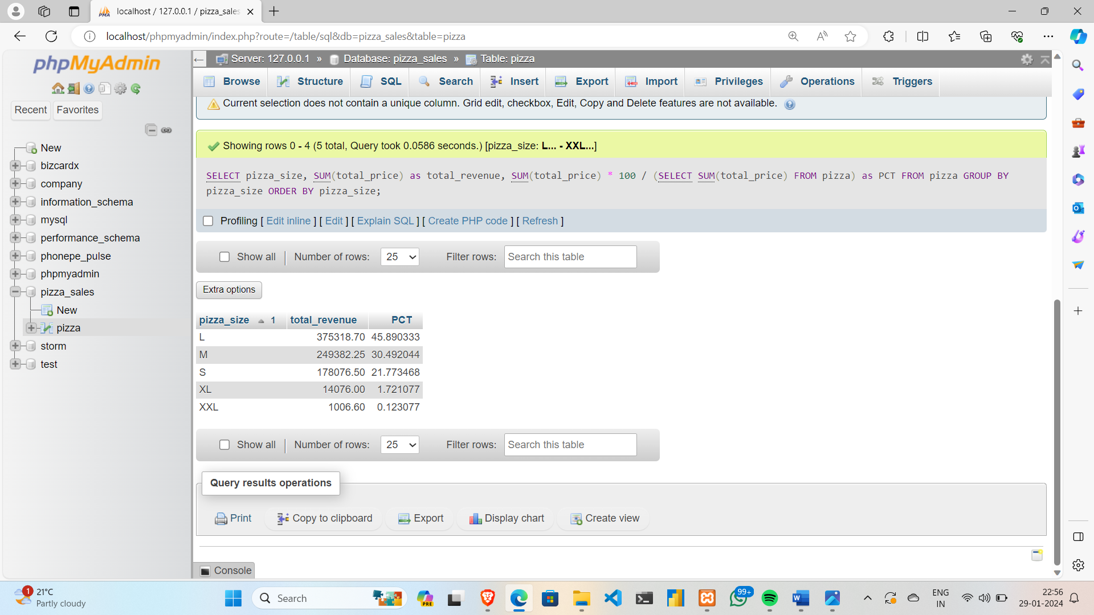

1. **Total pizzas sold by pizza category:**

**SELECT pizza_category, SUM(quantity)**

**as total_quantity_sold FROM pizza**

**GROUP BY pizza_category**

**ORDER BY total_quantity_sold desc**

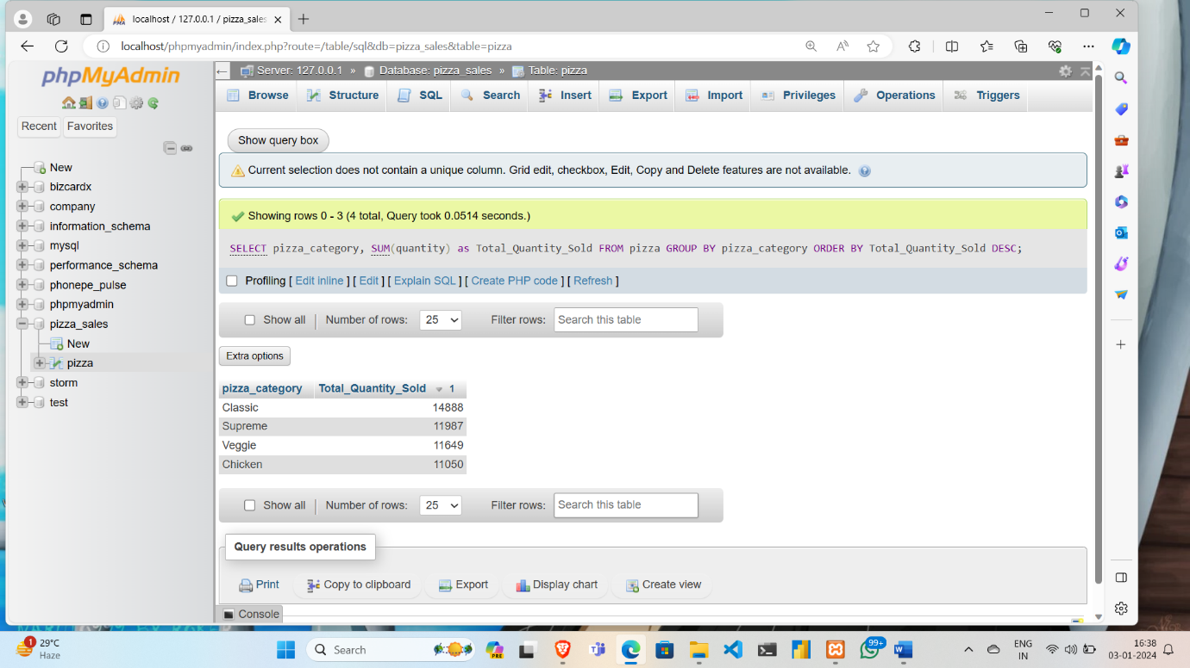

1. **Top 5 pizzas by revenue:**

**SELECT pizza_name, SUM(total_price) AS Total_Revenue FROM pizza**

**GROUP BY pizza_name**

**ORDER BY Total_Revenue DESC**

**LIMIT 5**

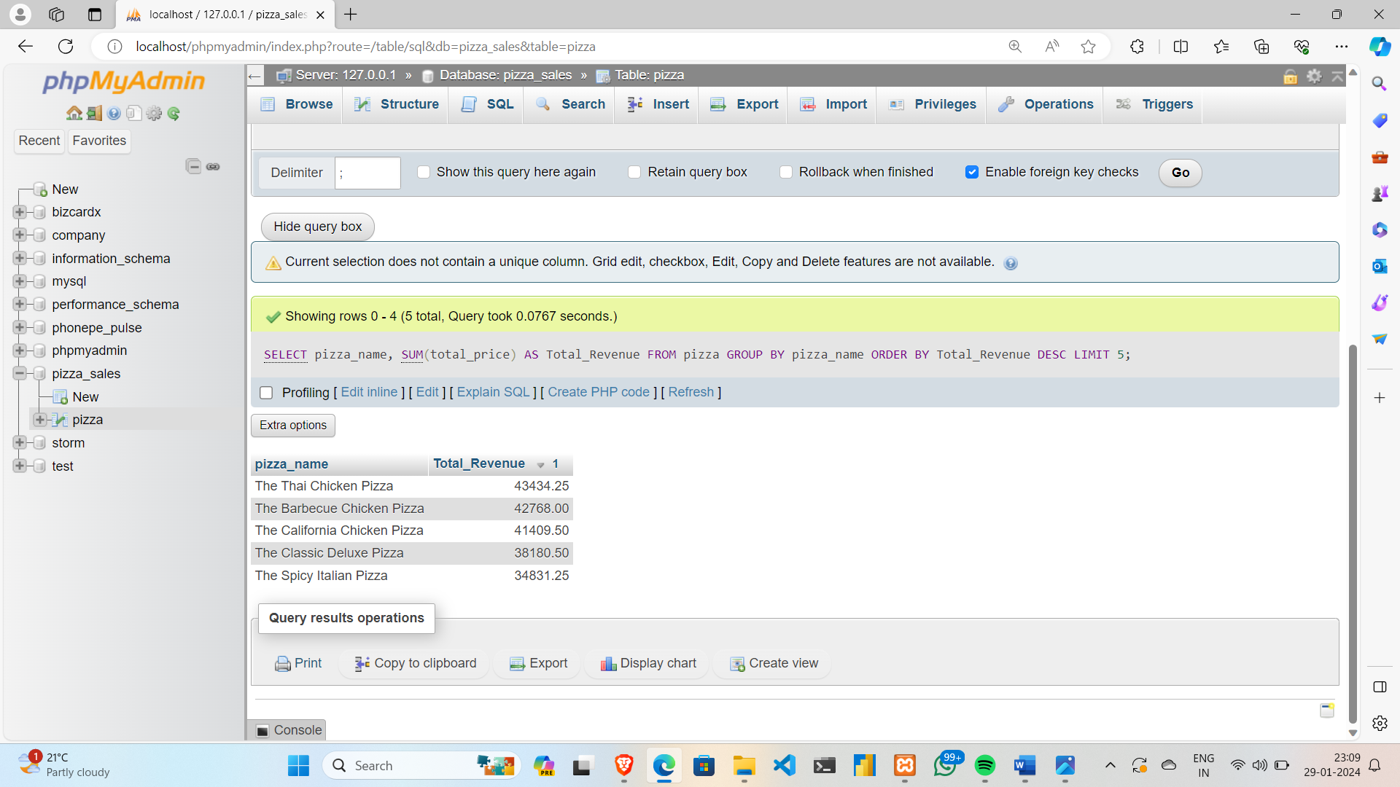

1. **Bottom 5 pizzas by revenue:**

**SELECT pizza_name, SUM(total_price) AS Total_Revenue FROM pizza**

**GROUP BY pizza_name**

**ORDER BY Total_Revenue ASC**

**LIMIT 5**

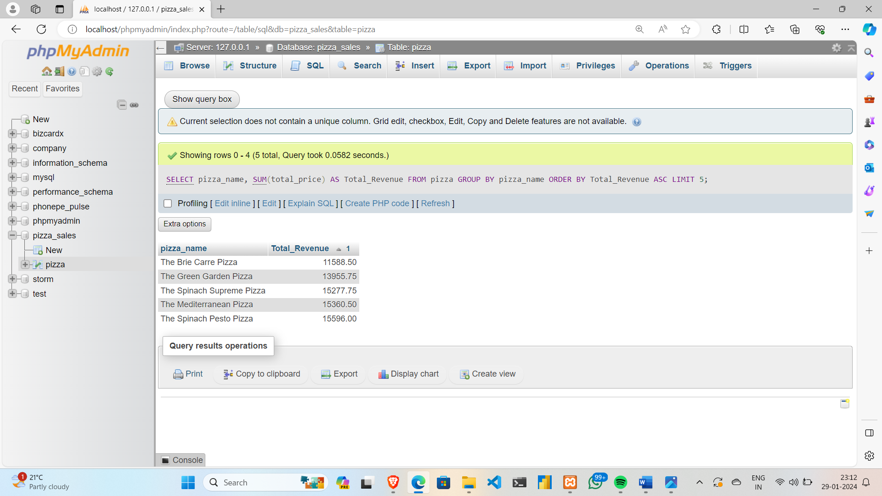

1. **Top 5 pizza by quantity:**

**SELECT pizza_name, SUM(quantity) AS Total_Pizza_Sold FROM pizza**

**GROUP BY pizza_name**

**ORDER BY Total_Pizza_Sold DESC**

**LIMIT 5**

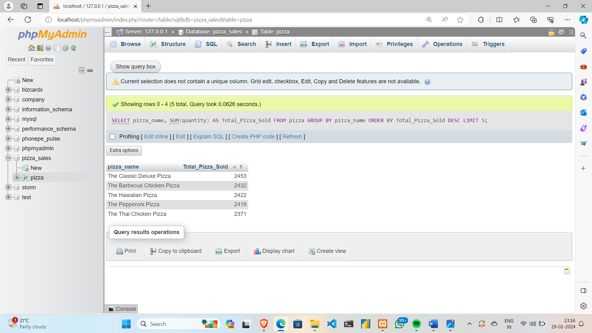

**9.Bottom 5 pizza by quantity:**

**SELECT pizza_name, SUM(quantity) AS Total_Pizza_Sold FROM pizza**

**GROUP BY pizza_name**

**ORDER BY Total_Pizza_Sold ASC**

**LIMIT 5**

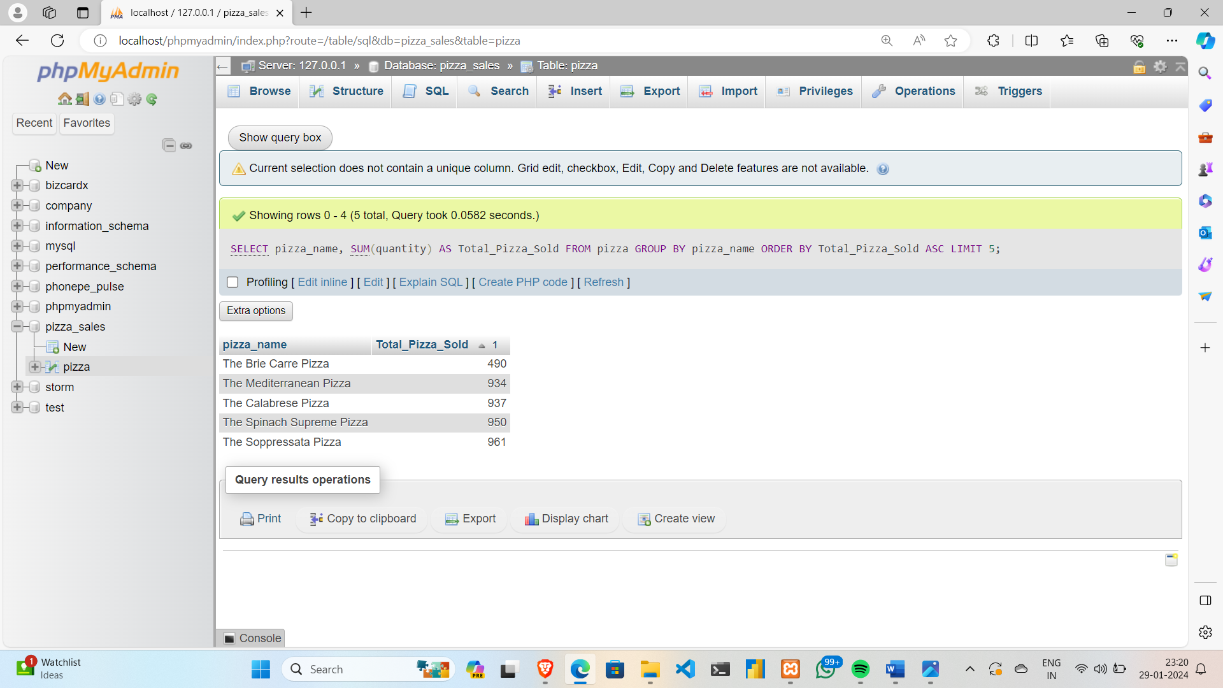

**10.Top 5 pizzas by Total Orders:**

**SELECT pizza_name, COUNT(DISTINCT order_id) AS Total_Orders FROM pizza**

**GROUP BY pizza_name**

**ORDER BY Total_Orders DESC**

**LIMIT 5**

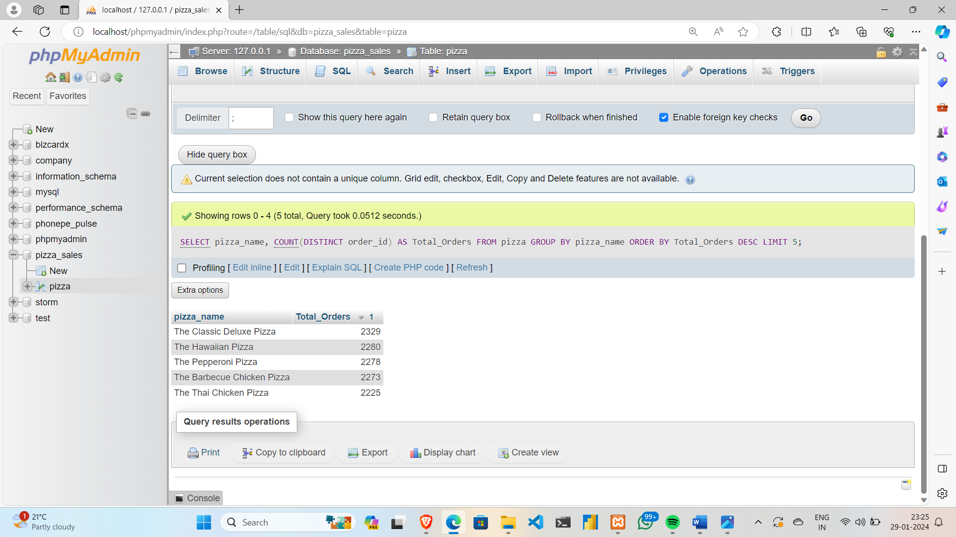

**11.Bottom 5 pizzas by Total Orders:**

**SELECT pizza_name, COUNT(DISTINCT order_id) AS Total_Orders FROM pizza**

**GROUP BY pizza_name**

**ORDER BY Total_Orders ASC**

**LIMIT 5**

